Facebook Ads services

Facebook is rapidly becoming one of the most powerful and cost effective ways to grow your business. With over 1 Billion members and more than half of that number online every day, it is an enormous prospecting and promotional resource.

Why use Facebook ads?
Along with tons of different ad types that you can use, the level of granularity you can get with Facebook targeting capabilities is amazing. Whether it is by behaviors, interests, demographics, connections, age ranges, languages, or locations, you can dig pretty deep with these targeting capabilities and layer them upon each other to ensure you’re getting rid of any questionable, out-of-market prospects and get to the exact target for your business.

Facebook is the best and cheapest way to feed your lead funnel. Once a prospect finds you through Facebook ads, you can continue to nurture that relationship until they know like and trust you enough to buy from you.

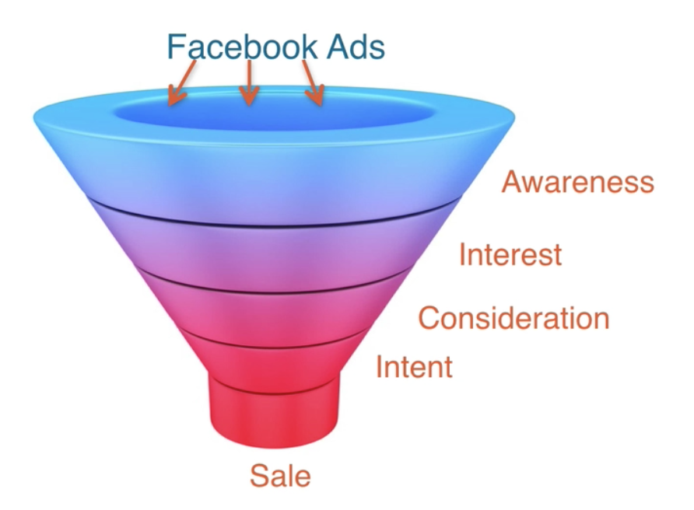
But running ad campaigns on Facebook can be complicated and changes frequently.

I have been running Facebook ads for clients and my own business for years and I KNOW WHAT WORKS. I have run successful campaigns from starting at $5/day all the way up to ones running for $1000/day.

Do you need to:
Get more ideal clients on an ongoing basis?
Get more people to your events?
Grow your email list?
Promote your launch?

Would you like to:
Show Facebook ads that have your ideal clients saying “That’s me!”
Month after month, watch as your list and revenue consistently skyrocket?
Have a consistent stream of highly targeted (and qualified) leads?

And all without ever having to worry about pixels, retargeting, stats, insights, or that ever-changing Power Editor!

We’ve got you covered.
Let us fill your list with super targeted leads to boost your latest product launch or grow your list with high-value clients.
We can make you a magnet for leads, clients, clicks and conversions.
You can boost your revenue and leads, without the stress or hassle of doing it yourself.

This is right for you if:
- Your first (or last) Facebook campaign was a total flop – and you’re just not willing to risk it again.
- You’ve tried (and tried and tried) to research how to set up ads on your own but it all sounds like a bunch of gibberish and you’re over trying to decode it yourself.
- You know you don’t have the time/energy/money or enough caffeine to learn all there is to know about Facebook ads – and frankly, you have little to no desire.
- You’re excited by what Facebook ads can do for your business – and are ready to hand the whole thing over to an expert who can get you tangible results!

Who is this for?
This service is best suited to businesses and coaches with an already established sales funnel that will benefit from an increased lead flow.

We take care of the whole process:
- Defining a complete Facebook ads strategy for your specific sales funnels, events, webinars, products, launches or list-building programs
- Creating compelling copy
- Setting up campaign in Power Editor
- Designing riveting images
- Managing Your Ads in Facebook Ads Manager
- Review of your landing pages to ensure they’re Facebook compliant

You will get:
- Weekly reporting on how your ads are performing
- Tweaking and testing of your ads to get the best cost per conversion
- Monthly conference calls
- An entirely stress-free experience with amazing results!

Investment starts at $1000
We have multiple packages to best serve your needs
Schedule a consultation phone call and let’s talk about how we can help you(Link to Time Trade)

